**CS3081 – Computational Mathematics**

**Recommended Questions Solutions**

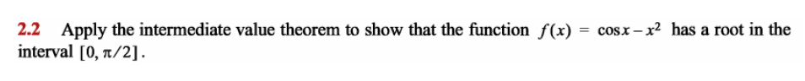

The intermediate value theorem states that if is continuous on the closed interval [a,b] and M is any number between and then there exists a c in [a,b] such that .

Consider the initial point of the interval:

Consider the final point of the interval:

The value of the function is positive in the initial point and negative at the final point. Thus, the function changes sign at some point during the interval. Therefore there exists a point c such that:

Thus, the function has a root within the interval specified.

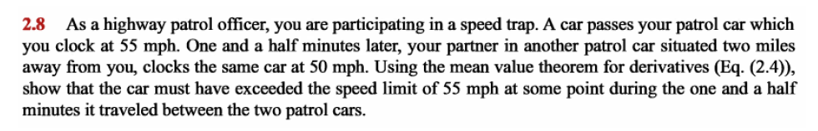

The mean value theorem states that if a function is continuous over the closed interval and differentiable over the open interval then there exists a number such that :

The position of the car is denoted as:

The distance between the two stations is:

The time travelled is 1.5 minutes so:

Plugging this into the above equation:

If denotes the position of the car, then denotes the speed of the car. As and the speed of the car at point c is 80mph, the car must have exceeded 55mph within the 1.5 minute interval.



Consider a function that is differentiable times in an interval containing the point .

The Taylor theorem states that for each in the interval, there exists a value between and such that:

Where called the remainder and is given by:

The Taylor series expansion of the function about (i.e ) is therefore as follows:

Substitute into this function:

Therefore, the Taylor’s series expansion of the function is:

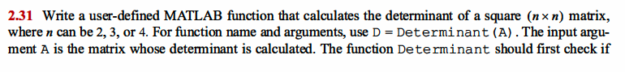

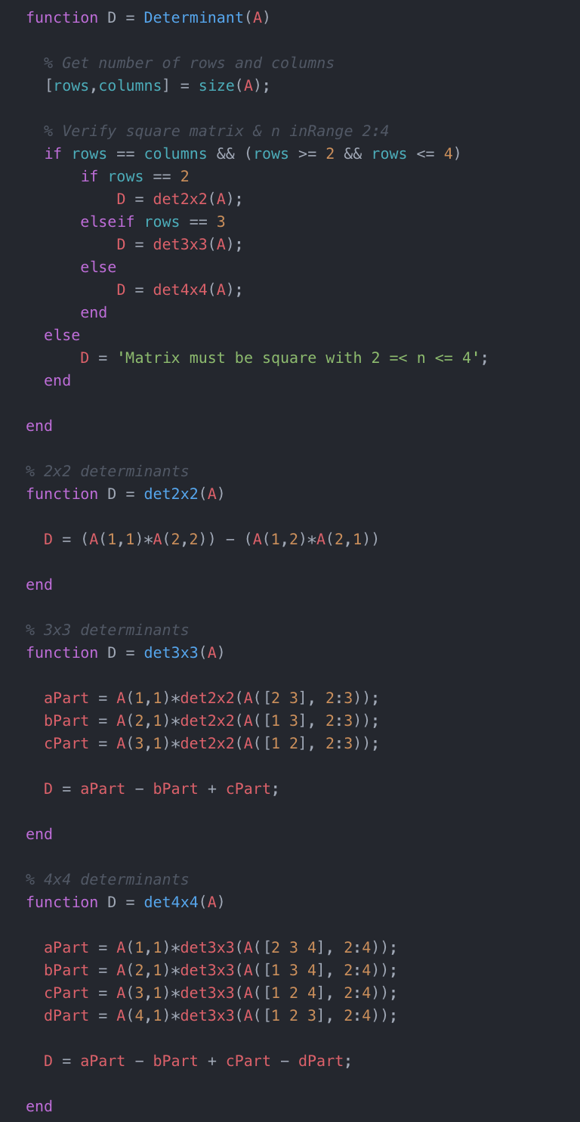

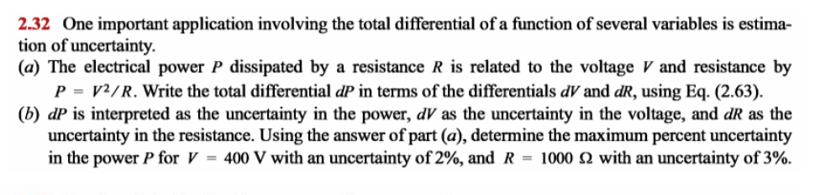

Eq 2.63:

a) Considering the electric power P dissipated by a resistance R is related to voltage V and resistance by:

We need to write the total differential in terms of the differentials and .

b) From the question we can infer:

Using this, we can replace them in the equation above as:

Therefore, the maximum percentage uncertainty in the power is 1.12%.

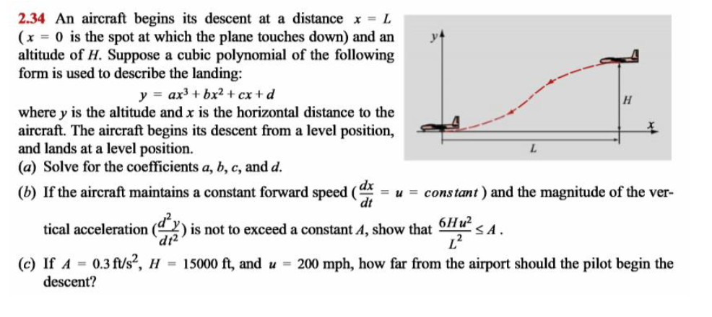

a) The height of the aircraft is described by the function:

At the distance , we know that the height of the aircraft is also 0. Therefore:

At the distance , we know that the slope of the aircraft is also 0. Therefore:

At the distance , we know that the slope of the aircraft is also 0. Therefore:

At the , we know that the height of the aircraft is H. Therefore:

Now, plug this back into the equation for a to get it in terms of just H and L:

b) First, re-write our equation with our newfound values:

Now, differentiate the above equation with respect to t:

Again, differentiating with respect to t to find the acceleration:

The value of does not exceed a constant A, therefore:

Since we can therefore infer that .

c) Given the following, calculate how far (x) the aircraft should begin its descent:

Consider the above relation:

Consider it in the form of:

We can then re-arrange this in terms of L:

Therefore, the pilot should begin his descent from a distance of from the airport.

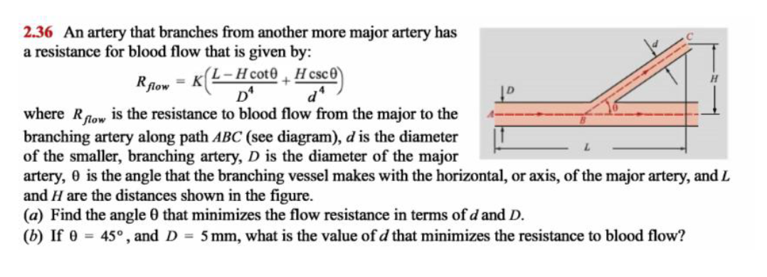

a) The resistance to blood flow is defined under the equation:

We need to find the angle that minimises the in terms of and . The derivative of with respect to the angle is:

Now, equating this with 0 we have:

Now, find the second derivative at the point as above:

Therefore when

the flow of resistance is at a minimum.

b) We need to find the value of d that minimises the resistance when:

Re-write the equation for in terms of d:

Therefore, for the resistance to blood flow is at a minimum.

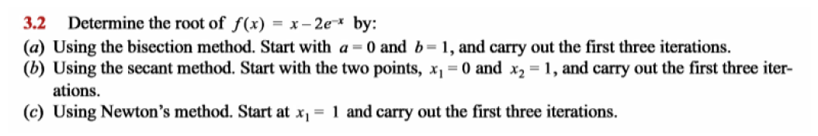

a) Starting with the two points a and b calculate f(a) and f(b)

Since the values of f(a) and f(b) are opposite signs, a solution lies within the range [0,1]. Calculate the average value of 0 and 1:

Therefore, the average value of 0 and 1 is 0.5. Now, calculate f(c):

Since the values of f(b) and f(c) are of opposite signs, the root lies between b and c. Calculate the average of b and c:

Therefore, the average value of 1 and 0.5 is 0.75. Now, calculate f(d):

Since the value of f(b) and f(d) are of opposite signs, a solution lies within the range of b and d. Calculate the average of these two values:

Therefore, the average value of 1 and 0.75 is 0.875. Now, calculate f(e):

b) In the secant method the following formula is used:

So for our given example we start off with and :

We can now solve for as follows:

We can calculate the absolute error as:

We can then calculate using the above equation and continue the iterations.

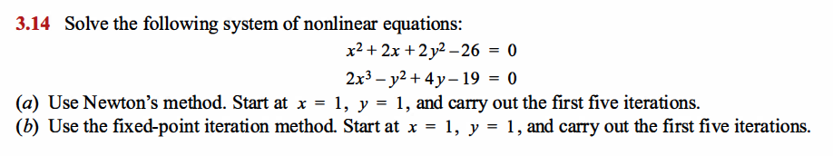

a) First, represent the equations as a function of x and y:

Partially differentiate and with respect to and :

Write the Jacobian matrix:

Substitute in the results from above:

Write the deltas:

Where for each iteration:

**For the first iteration w/ x=1, y=1:**

**For the second iteration w/ x=1.875, y=5.375:**

… Repeat steps as above until error (

b) First, we must re-arrange the equation in terms of x and y:

Re-arranging equation (1):

Re-arranging equation (2):

**For the first iteration w/ , :**

**For the second iteration w/ , :**

… Repeat steps as above until error (

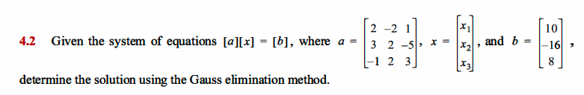

First, substitute the given matrices in form:

We then want to eliminate the all of the bottom row ( elements besides the 3 so that we can get a value for x3. Therefore perform the following row operations on matrices and :

* - 3()
* +
* -

From this we can now solve for :

We can then sub this into row 2 and solve for

And then solve for using row 1:

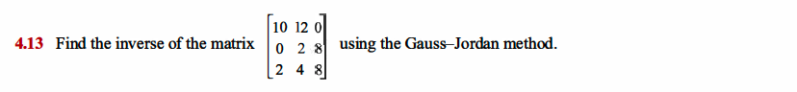

First write out the matrix and the augmented matrix:

The aim of the game here is to reduce the LHS matrix to the RHS matrix by performing row operations:



We know from 4.13 that the inverse of a is:

Consider the formula for the condition number of a matrix:

Where:

* denotes the norm of matrix a
* denotes the norm of inverse of matrix a

Write the formula to find the 1-norm of a matrix:

Consider the matrix a as stated above and 3 for n:

Therefore, the 1-norm of matrix a is 18.

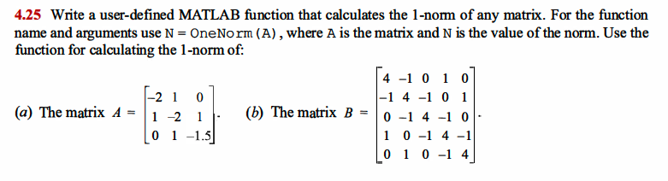



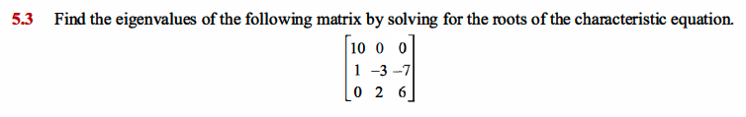

The expression for the characteristic equation to find the Eigen values is:

As the matrix a is of order 3x3, the order of the identity matrix is also 3x3:

Calculate the matrix :

Using this calculate the characteristic equation:

Therefore, the Eigen values of the matrix are 10, 4 and -1



For , the Eigen vector that is:

Calculate the next Eigen vector for

We must then extract the highest element from the vector and normalise the vector:

Therefore, the normalized unit vector of is

We then repeat these steps, for the next Eigen vector for

We must then extract the highest element from the vector and normalise the vector:

Therefore, the normalized unit vector of is

We then repeat these steps, for the next Eigen vector for

We must then extract the highest element from the vector and normalise the vector:

Therefore, the normalized unit vector of is

This is repeated and on our 6th iteration we get:

Since the difference between the multiplicative factors (was 3.01 for ) is relatively small we can terminate our iterations here at .

We can also say that the largest Eigenvalue for the given matrix a is:

**3.0165**

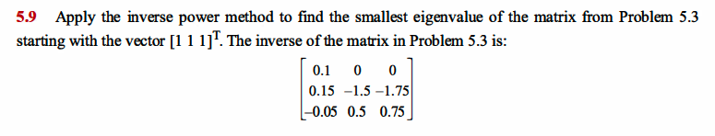

For , the Eigen vector that is:

Calculate the next Eigen vector for

We must then extract the highest element from the vector and normalise the vector:

Therefore, the normalized unit vector of is

We then repeat these steps, for the next Eigen vector for

We must then extract the highest element from the vector and normalise the vector:

Therefore, the normalized unit vector of is

These steps are repeated until the difference between the multiplicative factors becomes significantly small. In our case this happens to be when ’s multiplicative factor is -1 and ’s multiplicative factor is -1.0002. We can terminate the iterations here and confidently say this is approximately the largest Eigenvalue and Eigenvector.

We can also say that the largest Eigenvalue for the given matrix a is:

**-1**

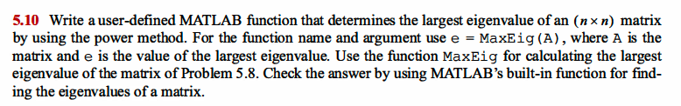



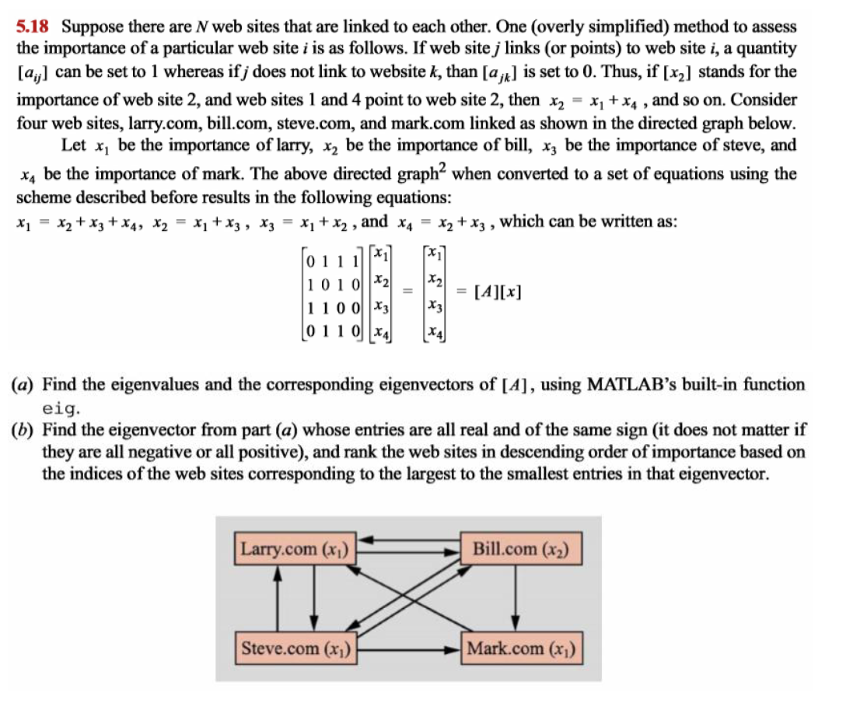

a) The MATLAB code is as follows:

This will return the following Eigenvectors in V:

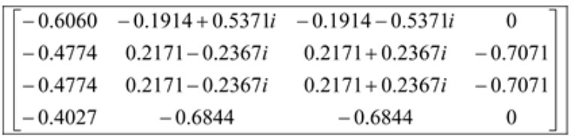

And this will return the following Eigenvalues in D:

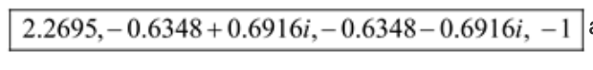

b) From the matrix of Eigenvectors the only entry which is real and all of the same sign is:

Assuming that the Eigenvectors indicate the importance of the website, they can be ranked in **descending order** as follows:

|  |  |
| --- | --- |
| Rank | Team |
| 1 |  |
| 2 | or |
| 3 | or |
| 4 |  |

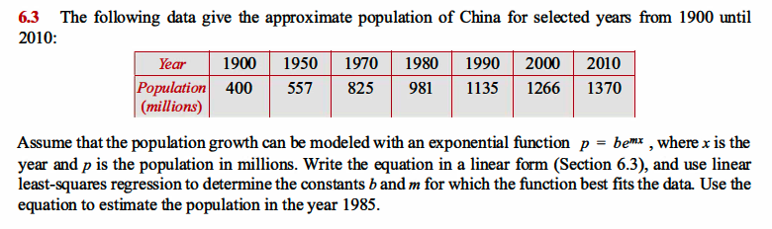

Consider the function:

Apply the natural logarithm on both sides to bring down the exponent:

Now, define the terms as follows:

We can now write the equation in linear form as:

Re-write the data in the table taking the natural logarithm of each entry:

|  |  |  |  |  |  |  |  |
| --- | --- | --- | --- | --- | --- | --- | --- |
| Year (x) | 1900 | 1950 | 1970 | 1980 | 1990 | 2000 | 2010 |
| Population ln(p) = Y | 5.9915 | 6.3226 | 6.7154 | 6.8886 | 7.0344 | 7.1436 | 7.2226 |

Now, apply the least square regression method. First, calculate the value of

Then, calculate the value of

Then, calculate the value of

Then, calculate the value of

Then, calculate the value of m

Then, calculate the value of B

Now, using our original equations solve the value of b:

Therefore, using our newfound values for b and m, the new relation is:

We can then, using this determine an estimation of the population in the year 1985 by letting x equal to 1985 in the above relation:

Therefore, we can estimate that the population in 1985 will be approximately 975.7718 million

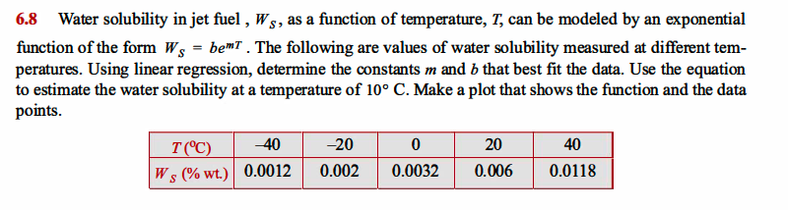

Consider the function:

Apply the natural logarithm to both sides:

Let:

We can now express our function as a linear expression (let T =X):

Re-write the data in the table taking the natural logarithm of each entry:

|  |  |  |  |  |  |
| --- | --- | --- | --- | --- | --- |
| Temp (X) | -40 | -20 | 0 | 20 | 40 |
| ln(Ws) (Y) | 6.7254 | 6.2146 | 5.7446 | 5.1160 | 4.4397 |

Now, apply the least square regression method. First, calculate the value of

Then, calculate the value of

Then, calculate the value of

Then, calculate the value of

Then, calculate the value of m

Then, calculate the value of B

Now, using our original equations solve the value of b:

Therefore, using our newfound values for b and m, the new relation is:

We can then, using this determine an estimation of the water solubility in jet fuel at a temperature of 10° C:

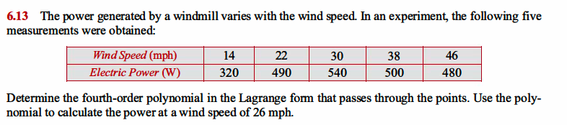

The n-1th order Lagrange polynomial passing through n points can be defined as:

This can also be written as:

Therefore, the 4th order Lagrange polynomial passing through the five points and is:

Using the data from the supplied table we then sub in the values for the following:

When we multiply this out, we are then left with the fourth order Lagrange polynomial as follows:

We can then use this polynomial to estimate the power at a wind speed of 26mph:

Thus, using the Lagrange fourth order polynomial we can estimate that the power at a wind speed of 26mph is approximately 528.18W.

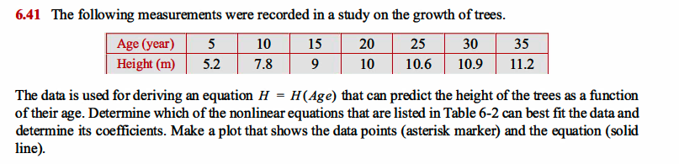

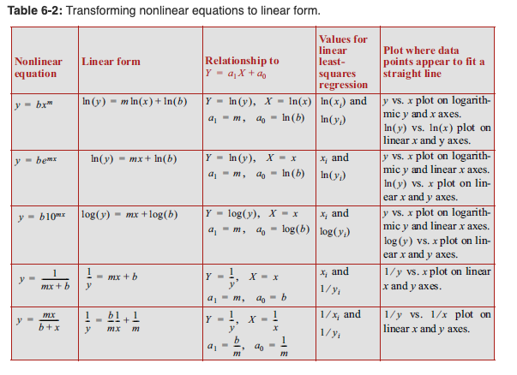

In order to choose which function would be best suited to model the above data points, first plot x vs y:

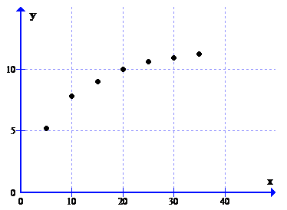

The scatter plot shows that the graph is similar to the nonlinear equation from the table:

The linear form of this equation is:

We can then consider this:

And from that, the equation can be considered linear as:

Now, apply the least square regression method. First, calculate the value of

Since X = 1/x, we then have:

Then, calculate the value of

Since Y = 1/y, we then have:

Then, calculate the value of

Then, calculate the value of

Then, calculate the value of M

Then, calculate the value of C

Now, using our original equations solve the value of m:

We can also solve the value of b:

Thus, we can now write our equation as:

By plotting the data points, and this given equation we can show that we have defined an accurate function to represent H=H(age):

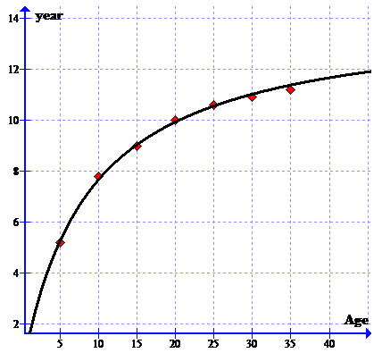

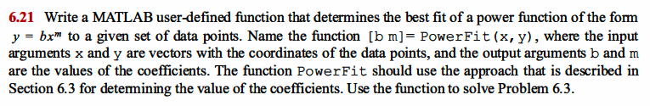

The exponential function is as follows:

This equation can be written in linear form as follows:

Now what we need to do is to determine the constants m and b. For a linear equation y = mx + b the coeffecients are:

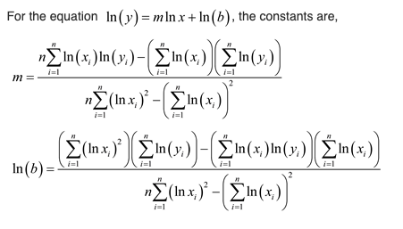

The MATLAB function PowerFit can be defined as follows:



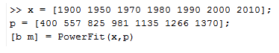

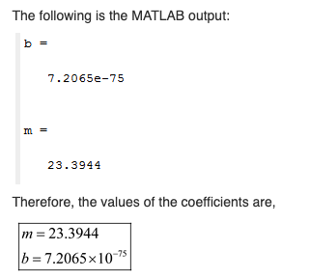

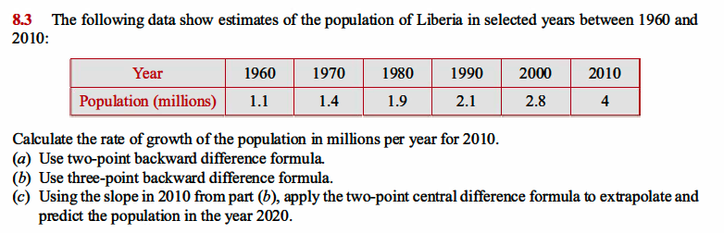

The formula for the two point backward difference formula for the first derivative is as follows:

We can neglect O(h) here. Then, substitute 2010 for and 2000 for and 10 for h (distance between points):

The formula for the three point backward difference formula for the first derivative is as follows:

We can neglect O(h) here. The, substitute 2010 for , 2000 for , 1990 for and 10 for h (distance between points):

The formula for the two point central difference formula for the first derivative is as follows:

We can neglect O(h) here. The, substitute 2010 for , for , 1990, 10 for h (distance between points) and we will solve for :

Therefore, our prediction for the population of Liberia in 2020 is approximately 5.7 million.

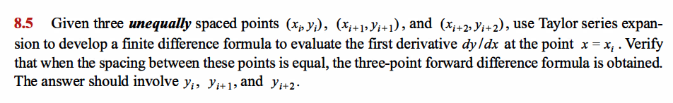

Consider three unequally spaced points .

Using Taylor series expansion, develop a finite difference formula, to evaluate the first derivative at the point

Given that the points are unequally spaced this means that we will have different values ofr h as follows:

Using the Taylor series expansion we can find the value of the function and its derivatives at point .

Multiply equation (1) by :

Multiply equation (2) by :

Subtract equation (2) from equation (1)

Re-writing this in terms of gives us:

Now consider the spacing between the points equal:

Using the Taylor series expansion find the values of the function and its derivatives at the point :

Now, multiply equation (3) by 4 as we want to eliminate the second and third derivatives:

Subtract equation (4) from equation 5:

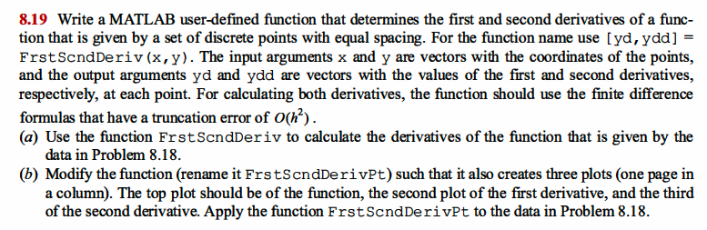

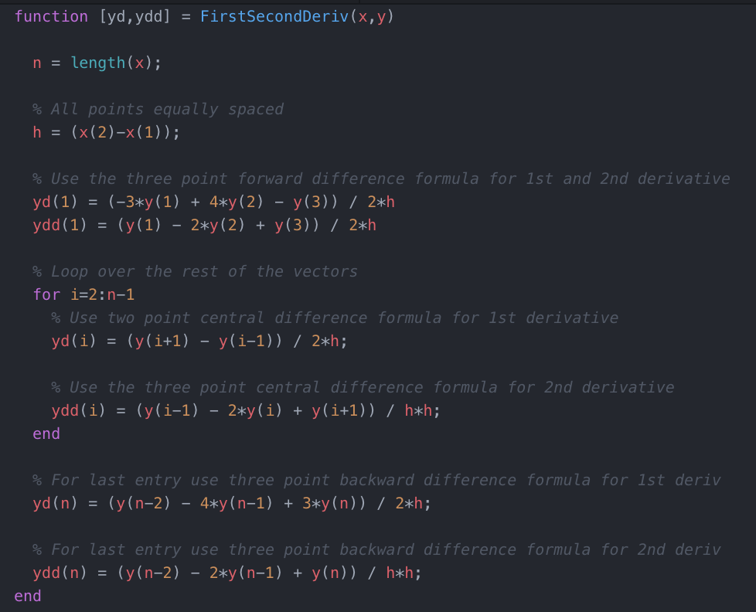

To then test this code to get the first and second derivatives do the following:

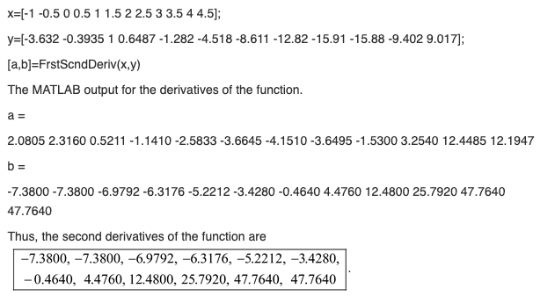

To then graph the results we would do the following:



This then produces the plots:

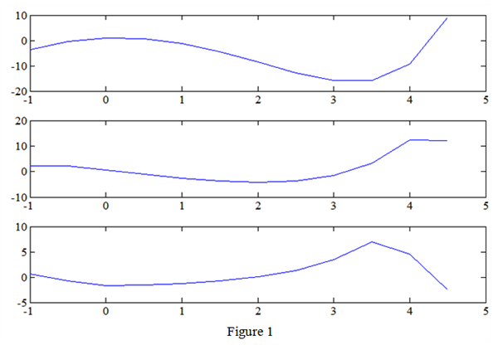

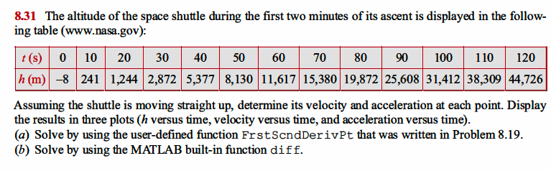

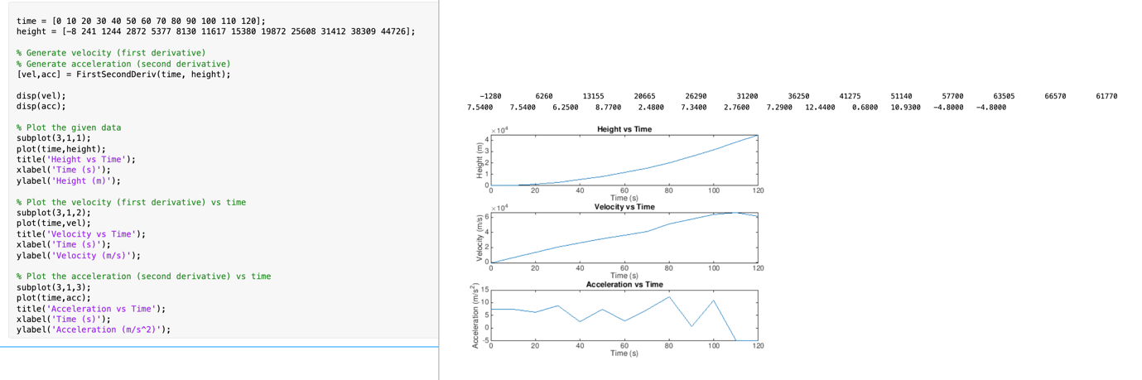

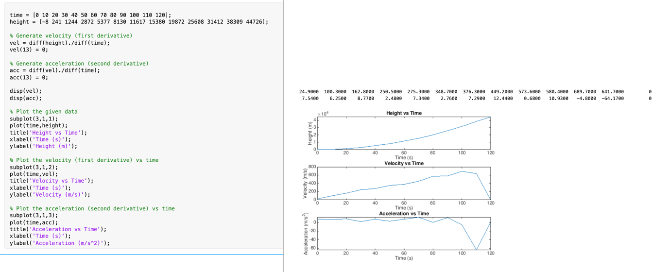

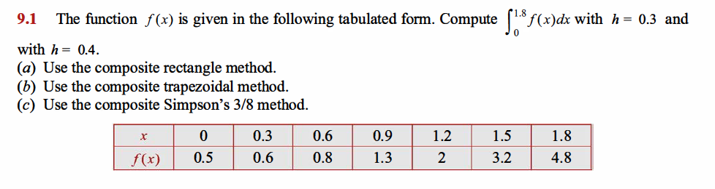

a) The formula to determine the integration using **composite rectangle method** is:

We can then determine N for h=0.3 as follows:

Obtain the summation of the data for h=0.3 and N=6:

We can then determine N for h=0.4 as follows:

We must first calculate the values of over 5 points with a width of 0.4 as follows:

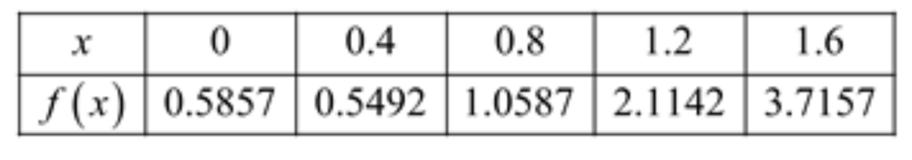

Obtain the summation of the data for h=0.4 and N=5:

b) The formula to determine the integration using composite trapezoidal method is:

For h=0.3 and N=6 we have:

For h=0.4 and N=5 we have:

c) The formula to determine the integration using Simpsons method is:

For h=0.3 and N=6 we have:

For h=0.4 and N=5 we have: